Designing a Mission Patch

TEACHER GUIDE
Background
While in training, the crew of every Space Transport System (STS) designs a patch that identifies its unique mission. The crew members for each mission, who usually consist of the commander, a pilot, mission specialists, and payload specialists, each contribute to the patch design. The team uses color, shapes, images, and text to represent different aspects of their mission so that it is truly unique and specific to their mission. The Student Worksheet provides two examples of mission patches.

Skills
- Team building
- Team patch design

Objectives
Students will:
- Identify attributes of mission patches.
- Design, draw, and describe the attributes of their own mission patch.
Activity Overview
Students will work in teams of four. They will read two mission patch descriptions and look over examples of the patches. Using shape, color, images, and text, each team will design their own mission patch.

NOTE: The patch should be no larger than a 5” by 9” design or shape.
Key Question
How can a team create a graphic design that represents all of the members, along with the team mission?
Materials
- Mission Patch Descriptions
- Drawing supplies

Procedures
- Divide students into teams of four.
- Using a thinking web or concept map, have students brainstorm ideas for their mission patch.
- Once students have developed some ideas, they need to come to a consensus on how to design the patch. Note: Because this is a team-building activity, it is important to let students come to a consensus rather than to vote on the design.
- Once consensus has been reached, students will begin designing their patch.
- Once students have completed their patch design, assemble a gallery of patches on the wall.
- Once all the patches are on the wall, have students do a gallery walk.
- Have students look at each patch and write down their interpretation of the design.
- Have students compare their interpretations of each design to the original patch description.

Management
This activity can be completed in one class period.

Reflection & Discussion
  - If you will all be flying the same mission, how come each of the patches are different?
  - What was difficult about reaching a consensus?
  - What kind of consideration went into planning your class project?

  - How can visual images inspire teamwork and group missions?

Transfer & Extension
- Research past shuttle missions and their mission patches. Have students try to interpret the patch design as it relates to the mission goals. This provides a nice historical overview of some of NASA’s past space endeavors.

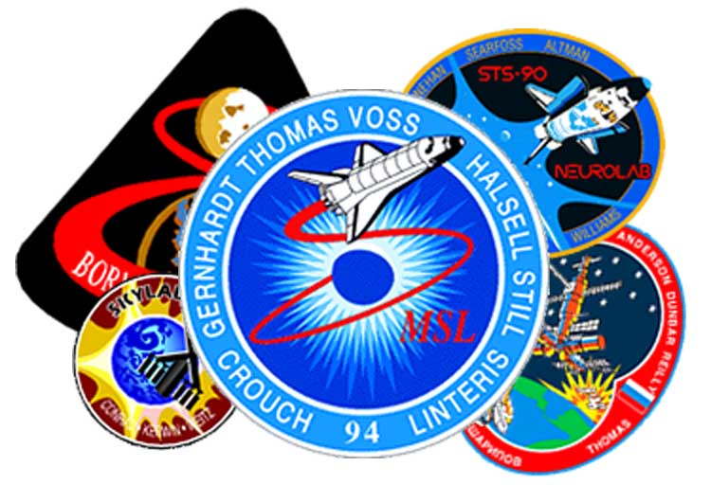
Designing a Mission Patch

STUDENT WORKSHEET
For each mission that goes to space, NASA creates a mission patch that the astronauts and mission team members all wear it on their uniforms. In fact, each of the astronauts helps to contribute to the overall design of the mission patch. The Mission Patch attempts to capture in colorful pictures and symbols the goals of the mission and its hopes for the future. The patches have unique shapes, include text, and are often very colorful. In this activity, you will work to design a Mission Patch for your upcoming Lunar Quest mission. The final Mission Patch you send to Mission Control may be a composite of ideas or one patch selected as most representative of your class as a whole. Check out the sample mission patches below.
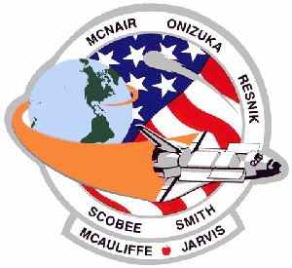
STS 51-L CREW INSIGNIA - This mission patch symbolizes the mission of the shuttle flight 51-L, to fly and to teach. The shuttle, being launched from the United States of America, encircles the planet to signify its U.S. presence in space to explore new frontiers. The shuttle in flight with open cargo doors represents the 51-L mission to launch a communication satellite (TDRSS), to collect data from Comet Halley, and to conduct scientific experiments. The apple next to the teacher’s name signifies the educational mission of the crew to touch the future through the lessons taught in space. The scene is encircled by the surnames of the crew members. They were astronauts Francis R. (Dick) Scobee, commander; Michael J. Smith, pilot; Ron McNair, Ellison Onizuka, and Judy Resnik, all mission specialists; Greg Jarvis, payload specialist; and Christa McAuliffe, teacher.
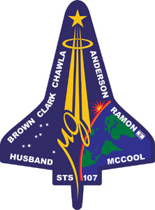
STS107 CREW INSIGNIA- This patch represents the multi-discipline microgravity and Earth science research mission objectives. The central element of the patch is the microgravity symbol, µg. The Sunrise is representative of the numerous experiments that are the dawn of a new era for continued microgravity research on the ISS and beyond. The constellation Columba (the dove) was chosen to symbolize peace on Earth and the Space Shuttle Columbia. The seven stars also represent the mission crew members and honor past astronauts. The Israeli flag is a symbol of the first person from Israel to fly on the Space Shuttle. The crew members were astronauts Rick D. Husband, mission commander; Kalpana Chawla, mission specialist; William C. McCool, pilot, David M. Brown, Laurel B. Clark, and Michael P. Anderson, all mission specialists; and Ilan Ramon, payload specialist.

Procedure

Build team spirit. Demonstrate your team's energy and investigative creativity.

- Discuss with your teammates ideas you want to incorporate into your mission patch design. Work to come to a consensus about what details your patch will illustrate.

- Once your team has come to an agreement, design and decorate your mission patch.

The patch should include the following elements:
- A size no larger than 5” by 9”
- The name of your mission
- The date of your mission
- Something unique about the group flying the mission
- Something that pertains to the goals of the mission
Bring your mission patch with you. We display them in Mission Control at the Challenger Learning Center.

